**CC-112L**

**Programming Fundamentals**

**Laboratory 02**

**Introduction to C & Structured Program Development**

**Version: 1.0.0**

**Release Date: 24-07-2022**

**Department of Information Technology**

**University of the Punjab**

**Lahore, Pakistan**

**Contents:**

* Learning Objectives
* Required Resources
* General Instructions
* Background and Overview
  + C
  + Program Sequence
  + Arithmetic Operators
  + Relational Operators
  + if Statement
  + if…else Statement
  + Increment & Decrement Operators
  + Microsoft ® Visual Studio
* Activities
  + Pre-Lab Activity
    - MinGW installation
    - A simple C Program
    - Comments
    - Preprocessor Directive
    - Escape sequences
    - Execution Sequence of a Program
    - Arithmetic Operators
    - Task 01: Adding Two Numbers
    - Task 01: Arithmetic Expressions
  + In-Lab Activity
    - Execute C program with Command Prompt
    - Relational Operators
    - if Statement
    - Multiple if Statement
    - if…else Statement
    - if…else if Statement
    - Increment and Decrement Operators
    - Task 01: Find Largest Number
    - Task 02: Fill in the blank area
    - Task 03: Dry Run Program
    - Task 04: Find and Resolve Errors
    - Bonus Task: Add Digits
  + Post-Lab Activity
    - Task 01: Simple Calculator
* Submissions
* Evaluations Metric
* References and Additional Material
* Lab Time and Activity Simulation Log

**Learning Objectives:**

* C program
* Comments
* Escape Sequences
* Execution Sequence of Program
* Arithmetic Operators
* Execution of C in Command Prompt
* Relational Operators
* if Statement
* if…else Statement
* if…else if Statement
* Increment and Decrement Operators

**Resources Required:**

* Desktop Computer or Laptop
* Microsoft ® Visual Studio 2022

**General Instructions:**

* In this Lab, you are **NOT** allowed to discuss your solution with your colleagues, even not allowed to ask how is s/he doing, this may result in negative marking. You can **ONLY** discuss with your Teaching Assistants (TAs) or Lab Instructor.
* Your TAs will be available in the Lab for your help. Alternatively, you can send your queries via email to one of the followings.

| **Teachers:** | | |
| --- | --- | --- |
| Course Instructor | Prof. Dr. Syed Waqar ul Qounain | [swjaffry@pucit.edu.pk](mailto:swjaffry@pucit.edu.pk) |
| Teacher Assistants | Usman Ali | [bitf19m007@pucit.edu.pk](mailto:bitf19m007@pucit.edu.pk) |
| Saad Rahman | [bsef19m021@pucit.edu.pk](mailto:bsef19m021@pucit.edu.pk) |

**Background and Overview:**

**C:**

C is a general-purpose computer programming language. It was created in the 1970s by Dennis Ritchie, and remains very widely used and influential.

© <https://en.wikipedia.org/wiki/C_(programming_language)>

**Program Sequence:**

Statements are executed one after another in programming. The order in which these statements are executed is program sequence.

**Arithmetic Operators:**

Operators which perform mathematical operations such as addition, subtraction, etc.

**Relational Operators:**

Operators which create a relationship and compares values of the two operands.

**if Statement:**

if statement executes a block of a code, if a specific condition is true.

**if…else Statement:**

if…else statement executes two different blocks of code depending if a specific condition is true or false.

**Increment & Decrement Operators:**

The increment operator (++) and the decrement operator (--) add one to and subtract one from an integer variable.

**Microsoft ® Visual Studio:**

Microsoft ® Visual Studio is an [integrated development environment](https://en.wikipedia.org/wiki/Integrated_development_environment) (IDE) from [Microsoft](https://en.wikipedia.org/wiki/Microsoft). It is used to develop [computer programs](https://en.wikipedia.org/wiki/Computer_program), as well as [websites](https://en.wikipedia.org/wiki/Web_site), [web apps](https://en.wikipedia.org/wiki/Web_app), [web services](https://en.wikipedia.org/wiki/Web_service) and [mobile apps](https://en.wikipedia.org/wiki/Mobile_app).

Microsoft ® Visual Studio supports 36 different [programming languages](https://en.wikipedia.org/wiki/Programming_language) and allows the code editor and debugger to support nearly any programming language, provided a language-specific service exists. Built-in languages include C, C++, C++/CLI, Visual Basic, .NET, C#, F#, JavaScript, TypeScript, [XML](https://en.wikipedia.org/wiki/XML), [XSLT](https://en.wikipedia.org/wiki/XSLT), [HTML](https://en.wikipedia.org/wiki/HTML), and [CSS](https://en.wikipedia.org/wiki/Cascading_Style_Sheets). Support for other languages such as [Python](https://en.wikipedia.org/wiki/Python_(programming_language)), [Ruby](https://en.wikipedia.org/wiki/Ruby_(programming_language)), [Node.js](https://en.wikipedia.org/wiki/Node.js), and [M](https://en.wikipedia.org/wiki/MUMPS) among others is available via [plug-ins](https://en.wikipedia.org/wiki/Plug-in_(computing)). [Java](https://en.wikipedia.org/wiki/Java_(programming_language)) (and [J#](https://en.wikipedia.org/wiki/J_Sharp)) were supported in the past.

© <https://en.wikipedia.org/wiki/Microsoft_Visual_Studio>

**Activities:**

**Pre-Lab Activities:**

**MinGW installation:**

* Download MinGW from <https://sourceforge.net/projects/mingw/>

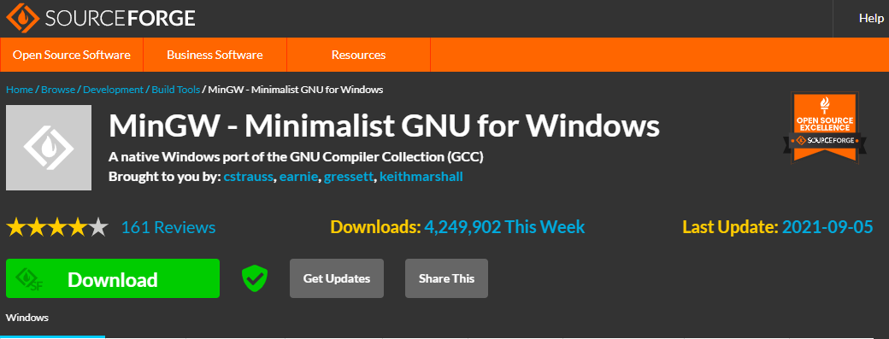

Fig. 01 (MinGW Installation)

* Double-click the downloaded file and follow the on-screen instructions for the installation
* When MinGW Installation Manager window opens, you'll see several packages in the upper-right panel. Check the boxes next to **"mingw32-base"** and **"mingw-gcc-g++"**

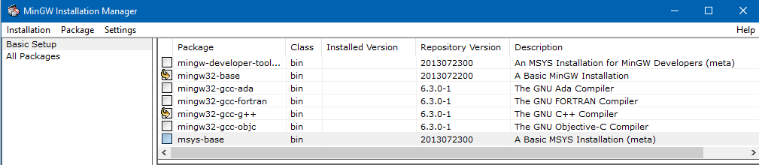

Fig. 02 (MinGW Installation)

* Click the **“Installation”** menu and select **“Apply Changes”**

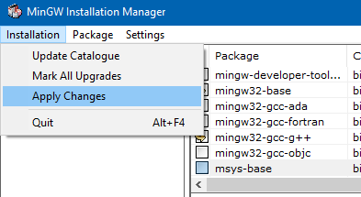

Fig. 03 (MinGW Installation)

* Press the **“Windows”** key and type **“environment”**
* Click **“Edit the system environment variables”**
* System Properties dialog will open. Click the **“Environment Variables…”** button



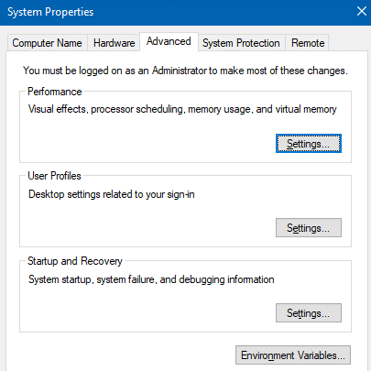

Fig. 04 (Environment Variable)

* Double Click **"Path"** option under **"System variables"**
* Click **“New”**
* Type **“C:\MinGW\bin”** and click OK

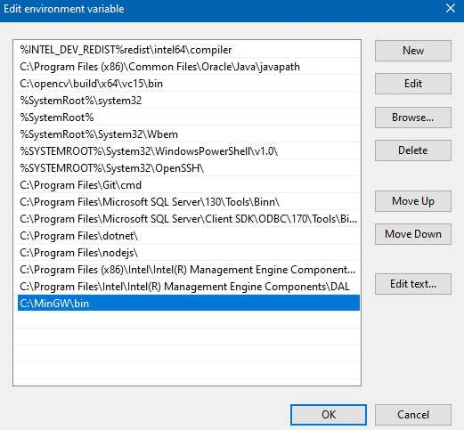

Fig. 05 (Environment Variable)

**A simple C program:**

A C program which prints a text.

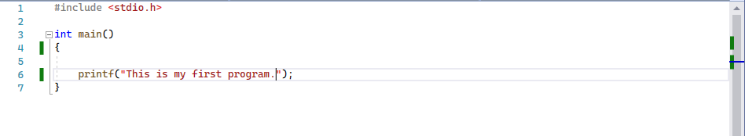

Fig. 06 (C program)

The output of above program will be a text line **“This is my first program.”**.

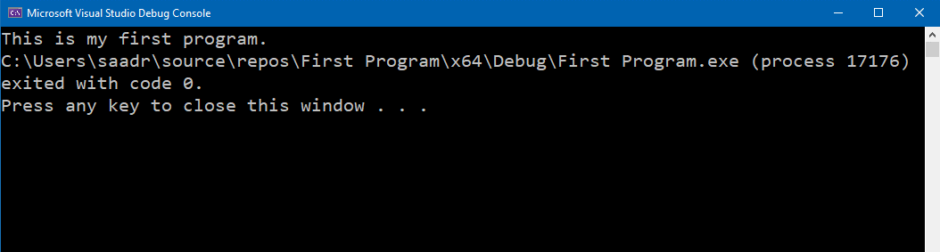

Fig. 07 (C program output)

**Comments:**

In C, line beginning with **“//”** is considered as a comment. Comments are added to improve the readability of the code. For commenting multiple lines **“/* … */”** is used where **/\*** is used in start and **/\*** is used in the end.

The green lines in the following code are comments.

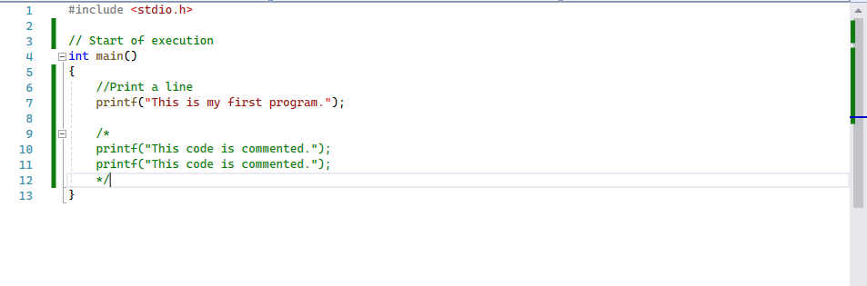

Fig. 08 (Comments in C)

**Preprocessor Directive:**

**“#include <stdio.h>”** is a C preprocessor directive. The preprocessor handles lines beginning with # before compilation. It tells the preprocessor to include the contents of the **“standard input/output header ()”**. The contents of headers will be explained in more detail in the upcoming manuals.

**The main Function:**

**“int main() { … }”** is a part of every C program. The parentheses after main indicate that main is a **function** (building block of a program). C programs must contain a main function. Execution of every program begins at the main function. Functions can return information. The keyword **“int”** to the left of main indicates that main returns an integer value.

**Escape sequences:**

The **“backslash (\)”** is an escape character in a string. It indicates that printf should do something different. Backslash combined with the next character to form an **escape sequence**. Some common escape sequences are:

| Escape sequence | Description |
| --- | --- |
| \n | Moves the cursor to the beginning of the next line. |
| \t | Moves the cursor to horizontal tab space. |
| \\ | \\ is required to insert a backslash character in a string. |
| \” | Strings are enclosed in double quotes, \" is required to insert a double-quote character in a string. |

Following example demonstrates the use of **“\n”** escape sequence. It is used in the **printf** statement to display text on two lines.

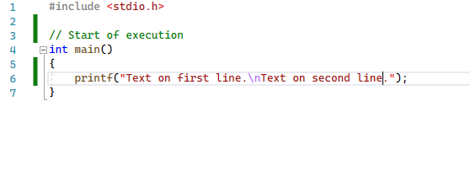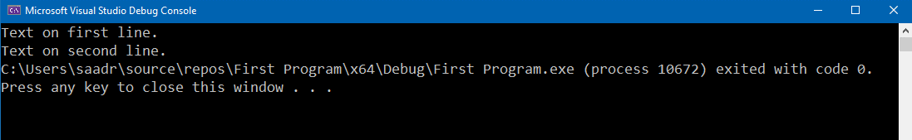

Fig. 09 (Escape Sequence Example)

**Execution Sequence of a Program:**

A program is executed line by line in a top to bottom fashion. The execution of a program starts from the main() function.

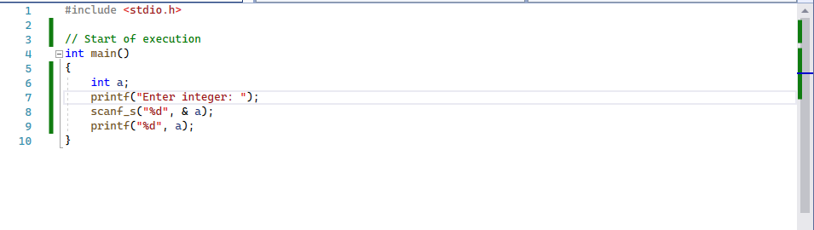

Fig. 10 (Execution Sequence)

The execution process of above program is as follows:

* The execution starts at line 4
* On line 6, an integer is defined
* Then line 7 is executed which prints **“Enter integer: ”** on the console and on the execution of line 8 program stops for user input

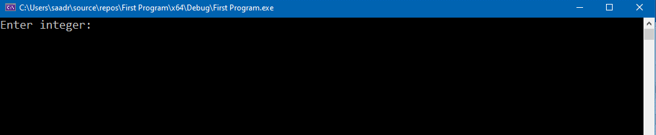

Fig. 11 (Execution Sequence)

* User enters an integer and press enter
* Then line 9 will be executed which prints the integer entered by the user
* The program ends

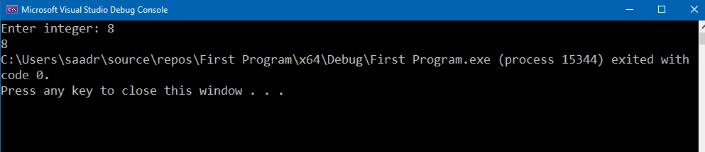

Fig. 12 (Execution Sequence)

**Arithmetic Operators:**

| Operation | Arithmetic Operator |
| --- | --- |
| Addition | + |
| Subtraction | - |
| Multiplication | * |
| Division | / |
| Modulus/Remainder | % |

The following program demonstrates the multiplication of two numbers and print the result on the console.

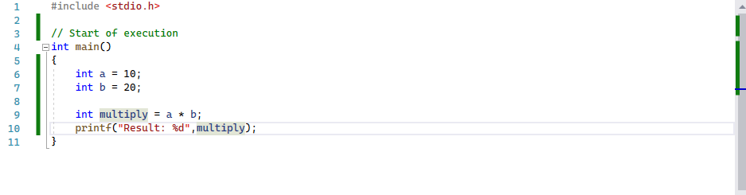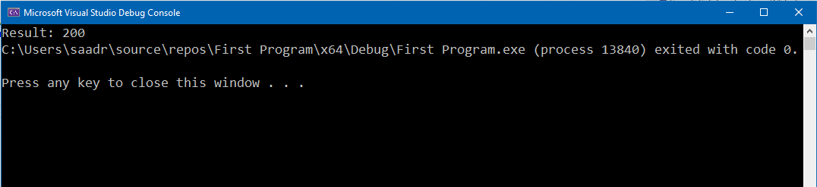

Fig. 13 (Arithmetic in C)

The **“Modulus (%) Operator”** returns the remainder after division. For example, if we divide 9 by 2 the remainder will be 1. Example is shown in the figure below:

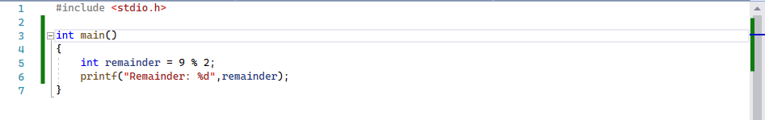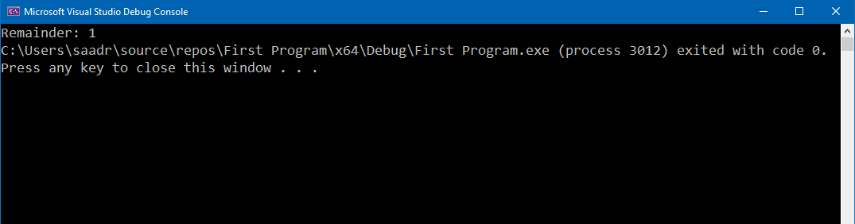

Fig. 14 (Arithmetic in C)

**Task 01: Adding Two Numbers [Estimated 15 minutes / 10 marks]**

Create a C program which:

* Takes two integers as an input from user
* Add both integers
* Display the Sum of integers on the Console as shown in figure

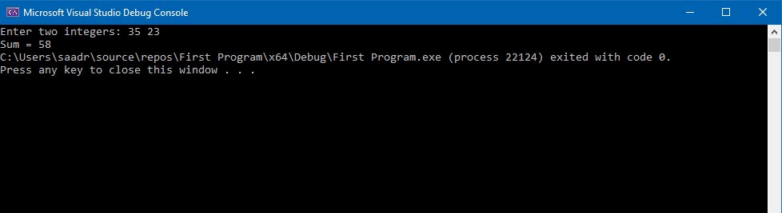

Fig. 15 (Pre-Lab Task)

* Submit **“.c”** file named your **“Roll No”** on Google Classroom

**Task 02: Arithmetic Expression [Estimated 15 minutes / 10 marks]**

Create a C program which:

* Takes take three integers as an input from user
* Solve the arithmetic expression **“(a + b x c) / 5”**
* Display the Result on the Console as shown in figure

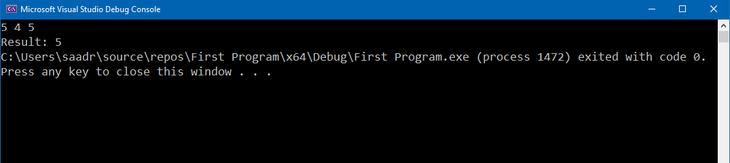

Fig. 16 (Pre-Lab Task)

* Submit **“.c”** file named your **“Roll No”** on Google Classroom

**In-Lab Activities:**

**Execute C program with Command Prompt:**

* Create a text file
* Name the text file to **“Program”** with extension **“.c”**
* Add the following code to the file

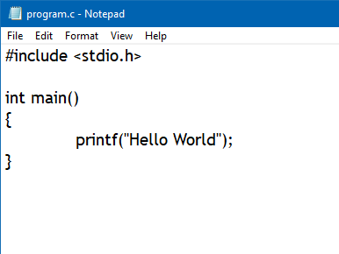

Fig. 17 (Execution in CMD)

* Open **“CMD”**
* Change directory to the path where you created **“Program.c”** file
* Type **“gcc Program.c -o Program.exe”,** where **“Program.c”** is your file name and **“Program.exe”** is the name, you want to give to the compiled program with **“.exe”** extension
* Press **“Enter”**

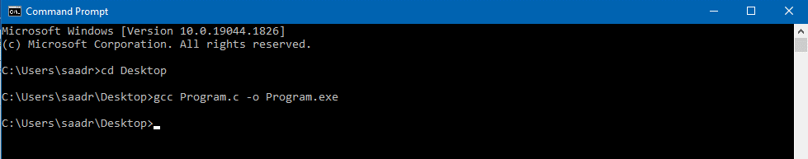

Fig. 18 (Execution in CMD)

* Type **“Program.exe”**. Press **“Enter”**. Your program will be executed

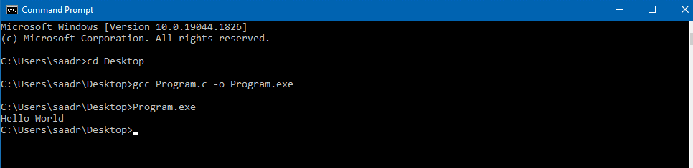

Fig. 19 (Execution in CMD)

**Relational Operators:**

| Operation | Relational Operator |
| --- | --- |
| Greater than | **>** |
| Smaller than | **<** |
| Greater than equal to | **>=** |
| Smaller than equal to | **<=** |
| Equal to | **==** |
| Not equal to | **!=** |

**if Statement:**

The if Statement runs a block of code if a condition is true. Its syntax is **“if (condition) {…}”**

In the figure below if Statement is used to compare (using **“==”** relational operator) two integers if they are equal or not.

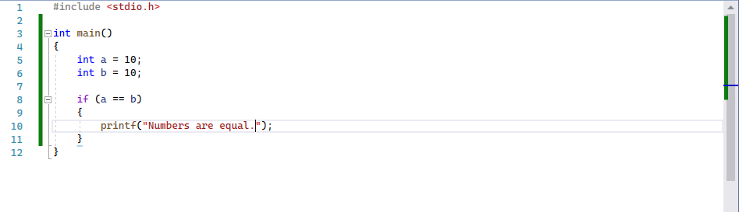

Fig. 20 (if Statement)

The console will display **“Numbers are equal.”** as the condition is true. If the condition is false then nothing will be displayed on the console.

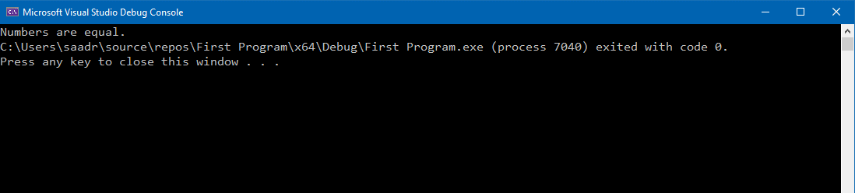

Fig. 21 (if Statement)

**Multiple if statement:**

Figure below shows an example code for multiple if Statement.

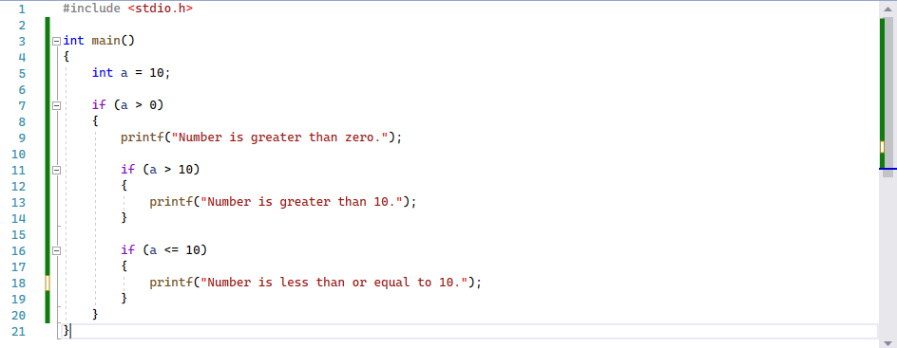

Fig. 22 (if Statement)

The execution of above program is as follows:

* At line 5, integer **“a”** is assigned value 10
* At line 7, it checks if condition, as it is true i.e., a is bigger than 0, so **“Number is greater than 0”** is displayed on the console
* At line 11, it checks if condition, as it is false, as a is not greater than 10, so program shifts to line 15
* At line 16, it checks if condition, as it is true i.e., a is equal to 0, so **“Number is less than or equal to 10”** is displayed on the console

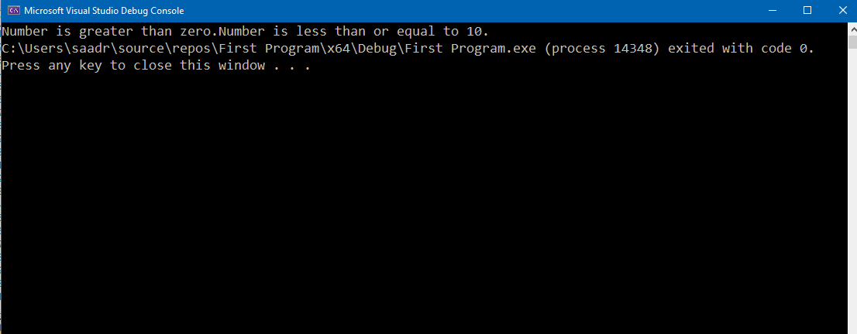

Fig. 23 (if Statement)

**if…else Statement:**

The if…else Statement runs a specific block of code depending if a condition is true or false. Its syntax is **“if (condition) {…} else {…}”.** Figure below shows an example code for if…else Statement.

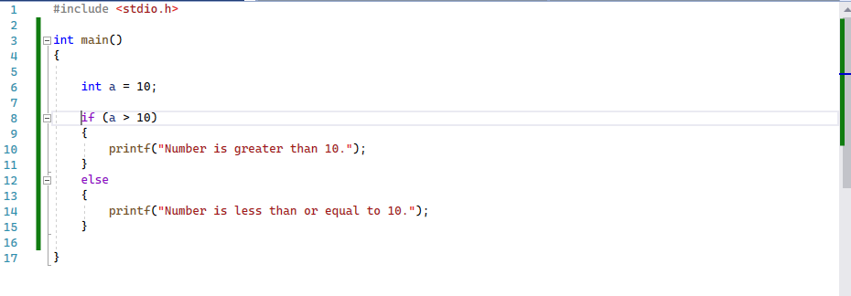

Fig. 24 (if…else Statement)

The execution of above program is as follows:

* At line 6, integer **“a”** is assigned value 10
* At line 8, it checks if condition, as it is false, as a is not greater than 10, so program shifts to line 12
* At line 12, it enters the else condition and **“Number is less than or equal to 10”** is displayed on the console

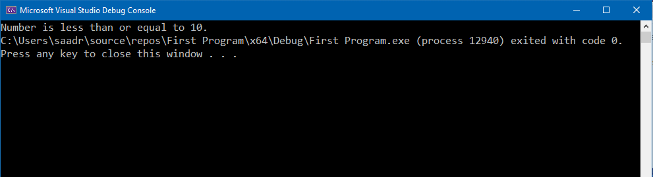

Fig. 25 (if…else Statement)

**if…else if Statement:**

The if…else if Statement runs a specific block of code depending if a any condition is true out of multiple condition or all conditions are false. Its syntax is **“if (condition) {…} else if(condition){…} else {…}”.** Figure below shows an example code for if…else if Statement.

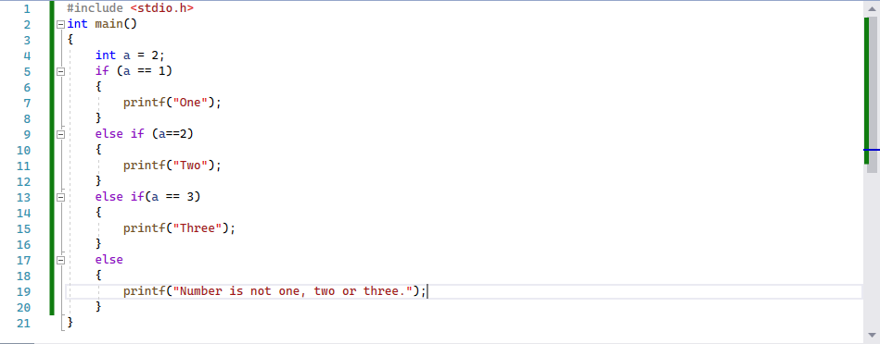

Fig. 26 (if…else if Statement)

The execution of above program is as follows:

* At line 4, integer **“a”** is assigned value 2
* At line 5, it checks if condition, as it is false, as a is not equal to 1, so program shifts to line 9
* At line 9, it checks if condition, as it is true, i.e., a is equal to 2 then **“Two”** is displayed on the console

If the value of a was **“5”,** then else portion will be executed as all conditions becomes false.

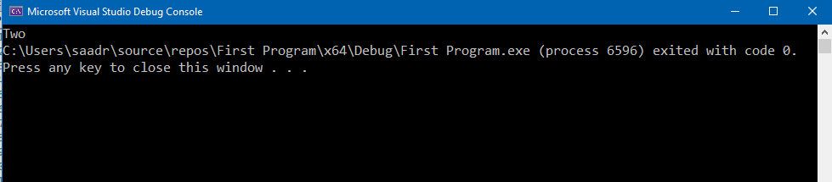

Fig. 27 (if…else if Statement)

**Increment and Decrement Operators:**

Increment Operator increase the value of integer by 1 while decrement operator decrease the value of integer by 1.

A coding example is shown below in figure:

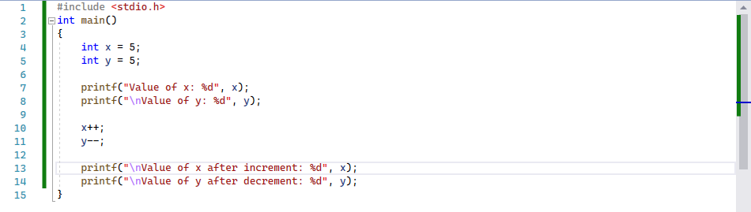

Fig. 28 (Increment and Decrement Operators)

The execution of above program is as follows:

* At line 4, integer **“x”** is assigned value 5
* At line 5, integer **“y”** is assigned value 5
* At line 7, value of x is displayed on Console
* At line 8, value of y is displayed on Console
* At line 10, value of x increased by 1 i.e., value of x becomes **“6”**
* At line 11, value of y decreased by 1 i.e., value of y becomes **“4”**
* At line 13, value of x is displayed on Console
* At line 14, value of y is displayed on Console

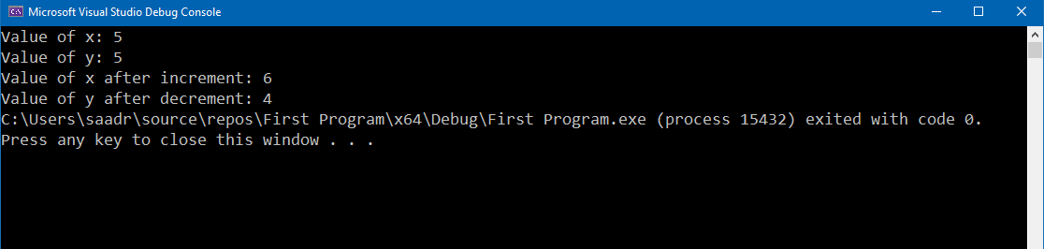

Fig. 29 (Increment and Decrement Operators)

**Task 01: Find Largest Number [40 minutes / 25 marks]**

Write a C program which: [Hint: Use Multiple if Statements]

* Reads three numbers as an input from user
* Find the largest number
* Displays **“Largest Number”** on the Console

| Input | Output |
| --- | --- |
| 2 3 4 | Largest number is 4 |
| 89 33 56 | Largest number is 89 |
| 10 33 33 | Largest number is 33. |

**Task 02: Fill the blank area [25 minutes / 25 marks]**

The following program:

* Take a **“obtained marks”** as an input from the user
* Displays grade corresponding to marks using following table:

| Criterion | Grade |
| --- | --- |
| Greater than equal to 85 | A |
| Greater than equal to 80 | A- |
| Greater than equal to 75 | B+ |
| Greater than equal to 70 | B |
| Greater than equal to 65 | B- |
| Greater than equal 59 | C |
| Greater than equal 54 | D |

And **“F”** otherwise.

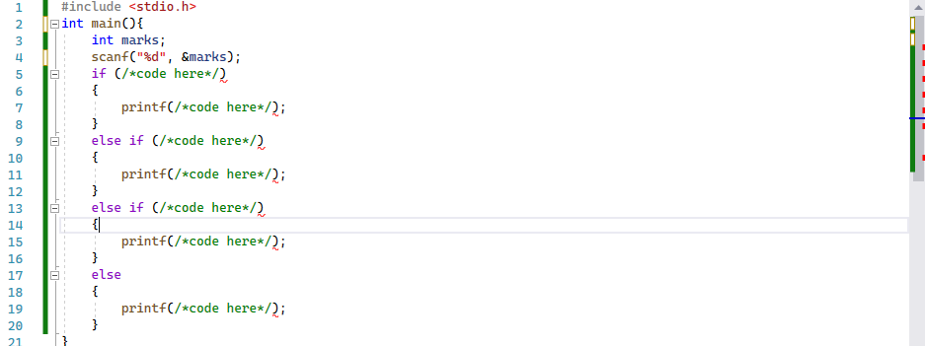

Fig. 30 (In-Lab Task)

| Input | Output |
| --- | --- |
| 88 | A |
| 67 | B- |

**Task 03: Dry Run Program. [30 minutes / 30 marks]**

Dry Run the following program and fill up the trace table:

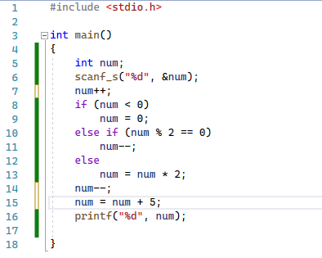

Fig. 31 (In-Lab Task)

| Input | num at line 7 | num at line 14 | Output |
| --- | --- | --- | --- |
| 1 | 2 | 0 | 5 |
| 23 |  |  |  |
| 6 |  |  |  |
| 72 |  |  |  |
| -12 |  |  |  |
| 0 |  |  |  |
| 99 |  |  |  |

**Task 04: Find and resolve the errors. [25 minutes / 20 marks]**

**(a):**

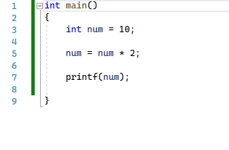

Fig. 32 (In-Lab Task)

**(b):**

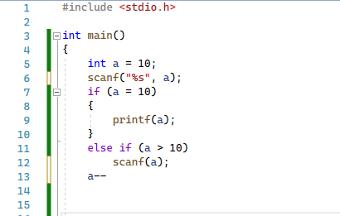

Fig. 33 (In-Lab Task)

**Bonus Task: Add Digits [10 marks]**

Read a 3-digit number from user. Add each digit and display the sum on the Console.

**Post-Lab Activities:**

**Task 01: Simple Calculator [Estimated 45 minutes / 30 marks]**

Create a Console based calculator which:

* Displays the menu on Console and takes an input from user as follows:

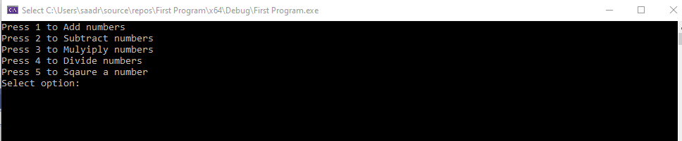

Fig. 34 (Post-Lab Task)

* If user enters **“1”** as an input then the program takes two numbers as input and display their addition on Console
* If user enters **“2”** as an input then the program takes two numbers as input and display their subtraction on Console
* If user enters **“3”** as an input then the program takes two numbers as input and display their multiplication on Console
* If user enters **“4”** as an input then the program takes two numbers as input and display their division on Console

If user enters **“5”** as an input then the program takes a number as input and display its square on Console [Hint: Use Multiplication]

* If user enter any other number then display **“Incorrect Number”**

**Submissions:**

* For In-Lab Activity: Save the files on your PC. TA’s will evaluate the tasks offline.
* For Pre-Lab & Post-Lab Activity: Submit the .c file on Google Classroom and name it to your roll no.

**Evaluations Metric:**

* All the lab tasks will be evaluated offline by TA’s
* **Division of Pre-Lab marks: [20 marks]**
* Add Two Numbers [10 marks]
* Arithmetic Expression [10 marks]
* **Division of In-Lab marks: [100 marks]**
* Task 01: Find Largest Number [25 marks]
* Task 02: Fill in the blank area [25 marks]
* Task 03: Dry Run Program [30 marks]
* Task 04: Find and Resolve Errors [20 marks]
* **Division of Post-Lab marks: [30 marks]**
* Task01: Simple Calculator [30 marks]

**References and Additional Material:**

* MinGW Installation

<https://sourceforge.net/projects/mingw/>

* if…else Statement in C

<https://www.programiz.com/c-programming/c-if-else-statement>

* Operators in C

<https://www.programiz.com/c-programming/c-operators>

**Lab Time Activity Simulation Log:**

* Slot – 01 – 00:00 – 00:15: Class Settlement
* Slot – 02 – 00:15 – 00:30: Execute C on Command Prompt
* Slot – 03 – 00:30 – 00:45: Execute C on Command Prompt
* Slot – 04 – 00:45 – 01:00: In-Lab Task
* Slot – 05 – 01:00 – 01:15: In-Lab Task
* Slot – 06 – 01:15 – 01:30: In-Lab Task
* Slot – 07 – 01:30 – 01:45: In-Lab Task
* Slot – 08 – 01:45 – 02:00: In-Lab Task
* Slot – 09 – 02:00 – 02:15: In-Lab Task
* Slot – 10 – 02:15 – 02:30: In-Lab Task
* Slot – 11 – 02:30 – 02:45: In-Lab Task
* Slot – 12 – 02:45 – 03:00: Discussion on Post-Lab Task